Ethical Hacking Assignment – 1

Submittted By

Tanishq Vyas

SRN : PES1201800125
Section : H
Semester : 7th
Dept : CSE

Machines:

- Attacker Machine

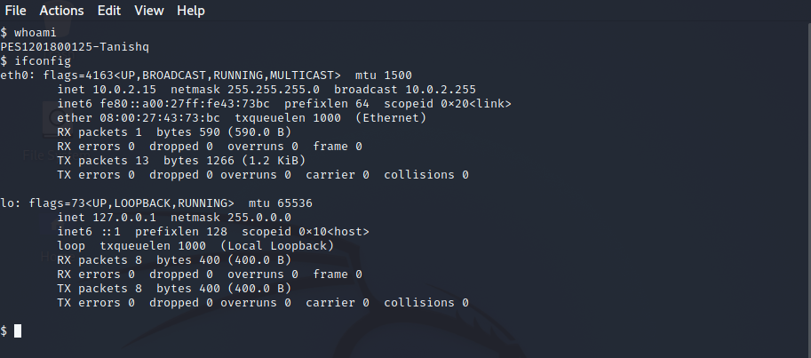

- Vulnerable Machine

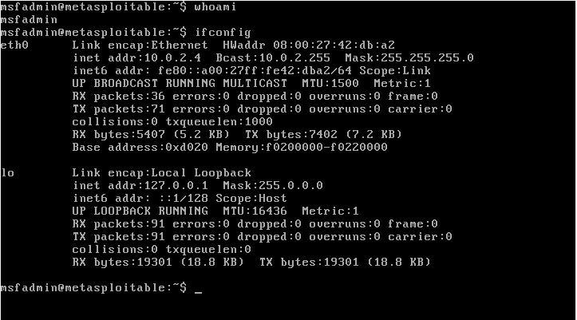

Attack Procedure:

- Finding IP of the target Machine
nmap -T4 -sP 10.35.1.0/24
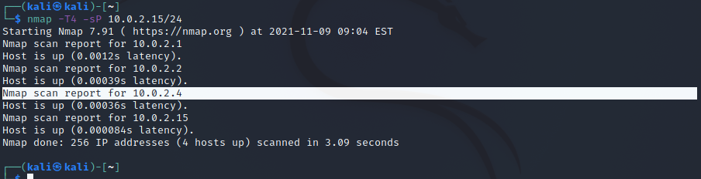
alternatively we can also use netdiscover commmand.

- Scanning for Vulnerabilities
nmap -p- -sV 10.0.2.4
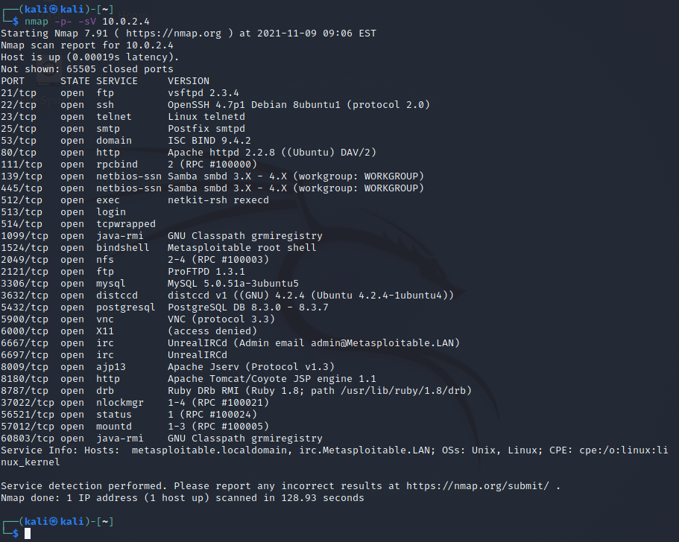

For this assignment we will be looking at the following two vulnerabilities:

1. UnrealIRCd
2. distccd v1

- Opening Metasploit

msfconsole

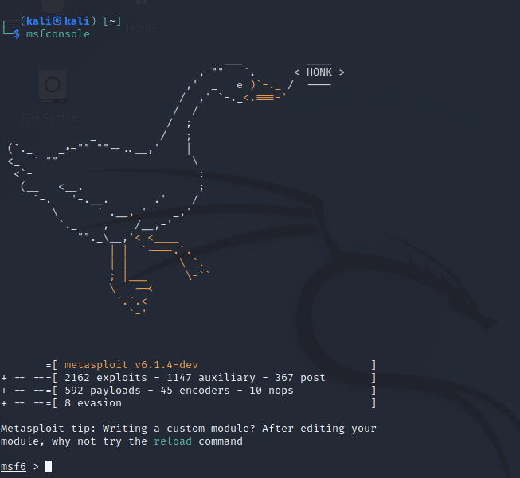

- Exploits
a) UnrealIRCd

Search for the exploit and use it.

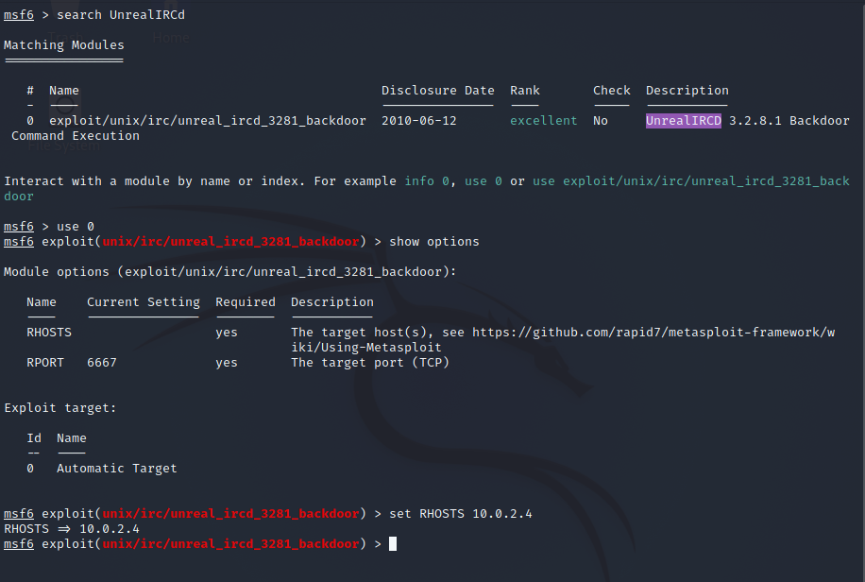
We set the RHOSTS to the target IP. The RPORT value is already set to the exposed port as seen in step 2. Now we shall set the payloads.

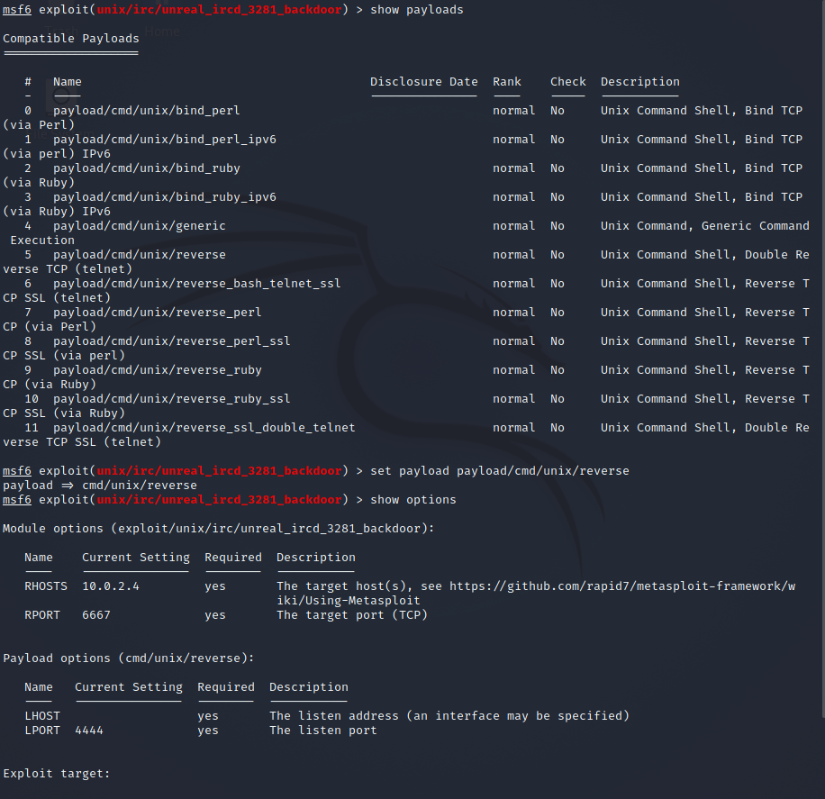

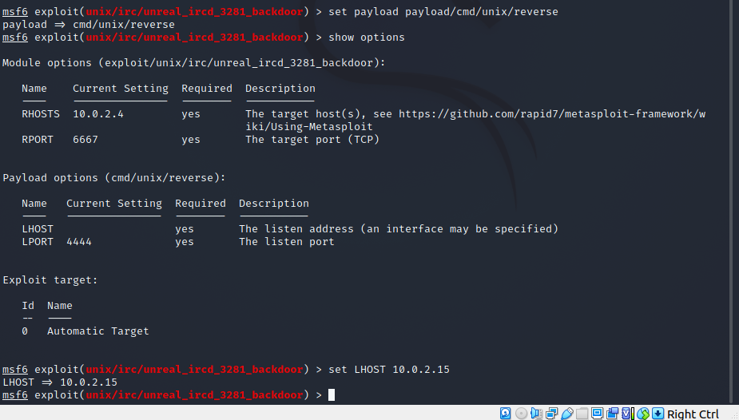
Now we run the exploit

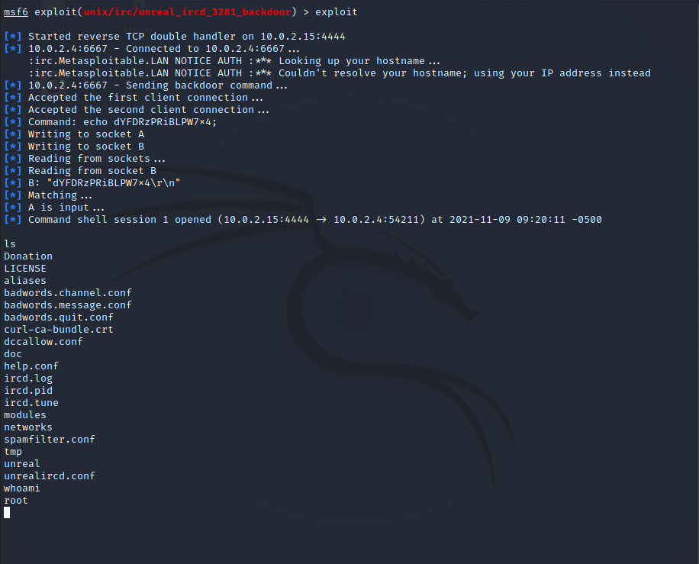
The exploit was successfull. We are able to access the target machine.

b) distccd v1

Search for the exploit and use it.

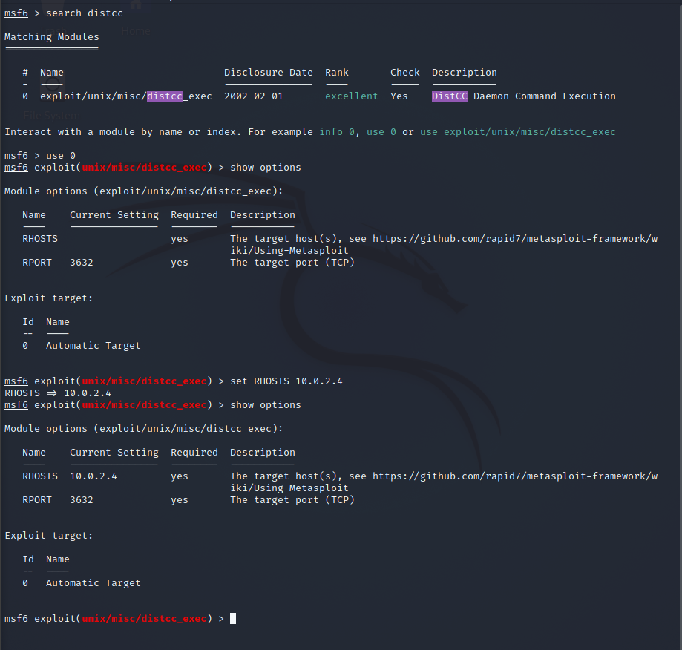
We set the RHOSTS to the target IP. The RPORT value is already set to the exposed port as seen in step 2. Now we shall set the payloads.

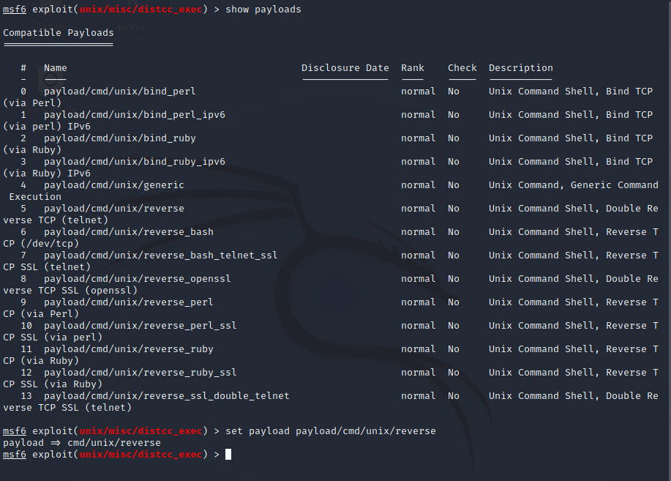
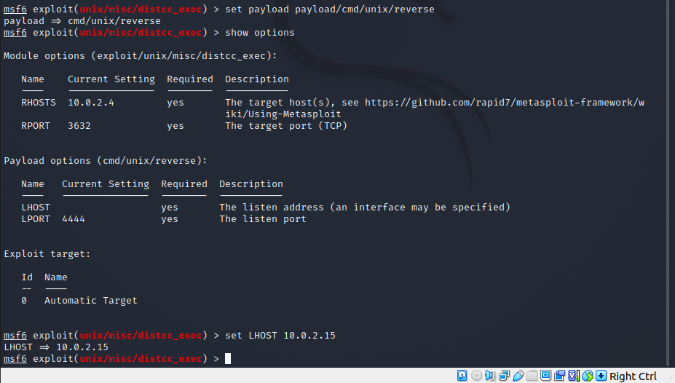

Now we run the Exploit

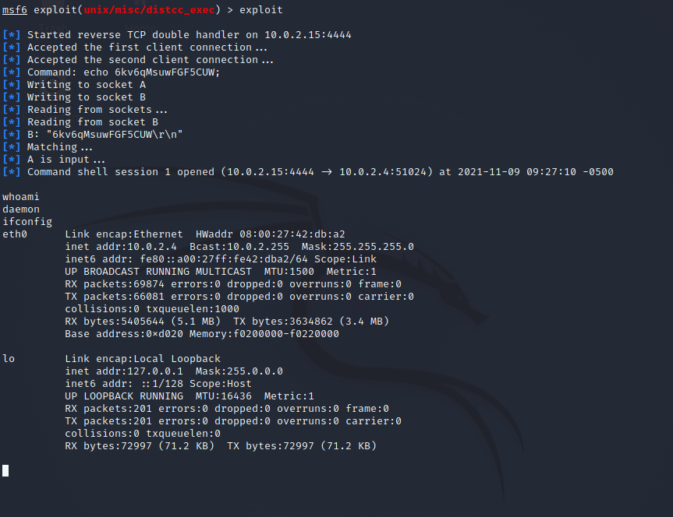
As we can see the exploit was successfull. Since we obtained the access to the target machine.

